To input the complete set of data, 6 ext_clock ticks are required, after the 6 sets of data have been input to the system, a signal START_COM activates the system signifying to the rest of the system to act upon the data.

3x3’s matrix multiplications

Input data

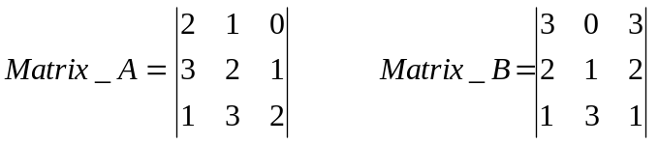 (3x3) by a (3x3) result is a 3x3

Decimal, 1 demensional equivalent of the matrices data 2 1 0 3 2 1 1 3 2 3 0 3 2 1 2 1 3 1

Bit stream 100100111001011110110011100110011101

Split the bit stream up into six bit segments starting with the LSB 100100 111001 011110 110011 100110 011101

Reverse each set of six bits, input into the XSport program 001001 100111 011110 110011 011001 101110

In MATRIX MODE 111/ 011 OR MATRIX MODE 7 / MATRIX MODE 3 the following matrix product is produced

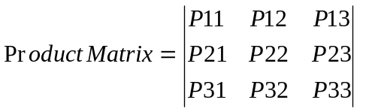

The Calculated matrix product is shown below:-

Calculated Answer:

(2 x 3) + (1 x 2) + (0 x 1) = 8
(3 x 3) + (2 x 2) + (1 x 1) = 14
(1 x 3) + (3 x 2) + (2 x 1) = 11

(2 x 0) + (1 x 1) + (0 x 3) = 1
(3 x 0) + (2 x 1) + (1 x 3) = 5
(1 x 0) + (3 x 1) + (2 x 3) = 9

(2 x 3) + (1 x 2) + (0 x 1) = 8
(3 x 3) + (2 x 2) + (1 x 1) = 14
(1 x 3) + (3 x 2) + (2 x 1) = 11

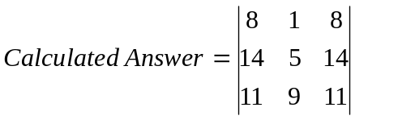

System Answer:

3BFF = 08
093A = 14
0912 = 11

3B92 = 01
3BEB = 05
3BFB = 09

3BFF = 08
093A = 14
0912 = 11

3B92 = 01 – MODE 7
OR
097F = 18 – MODE 3

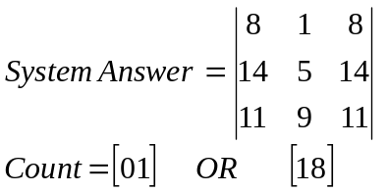

(2x3) by a (3x3) matrix multiplications

Input data

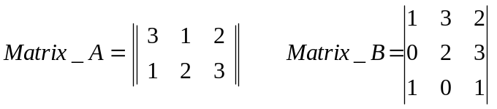 (2x3) by a (3x3) result is a 2x3

Decimal 1 dimensional equivalent of the matrices data 3 1 2 1 2 3 0 0 0 1 3 2 0 2 3 1 0 1

Bit stream 110110011011000000011110001011010001

Split the bit stream up into three bit segments starting with the LSB 110110 011011 000000 011110 001011 010001

Reverse each set of six bits, input into the XSport program 011011 110110 000000 011110 110100 100010

In MATRIX MODE 110 / 010 OR MATRIX MODE 6 / 2 the following matrix product is produced

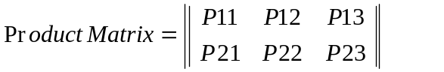

The Calculated matrix product is shown below:-

Calculated Answer:

(3 x 1) + (1 x 0) + (2 x 1) = 5
(1 x 1) + (2 x 0) + (3 x 1) = 4

(3 x 3) + (1 x 2) + (2 x 0) = 11
(1 x 3) + (2 x 2) + (3 x 0) = 7

(3 x 2) + (1 x 3) + (2 x 1) = 11
(1 x 2) + (2 x 3) + (3 x 1) = 11

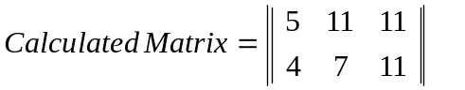

System Answer:

3BEB = 05
3BBA = 04

0912 = 11
3BD2 = 07

0912 = 11
0912 = 11

3B92 = 01 – MODE 6
OR
096B = 15 – MODE 2

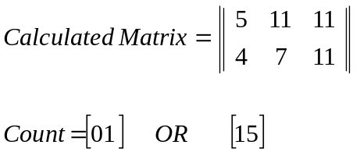

(2x3) by a (3x3) matrix multiplications

Input data

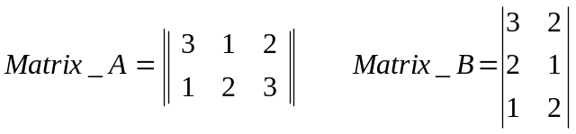 (2x3) by a (3x2) result is a 2x2

Decimal 1 dimensional equivalent of the matrices data 321123000320210120

Bit stream, made up of two bit numbers 111001011011000000111000100100011000

Split the bit stream up into three bit segments starting with the LSB 111001 011011 000000 111000 100100 011000

Reverse each set of six bits, input into the XSport program 100111 110110 000000 000111 001001 000110

In MATRIX MODE 101 / 001 OR MATRIX MODE 5 / 1 the following matrix product is produced



The Calculated matrix product is shown below:-

Calculated Answer:

(1 x 3) + (2 x 2) + (0 x 1) = 7
(3 x 3) + (2 x 2) + (1 x 1) = 14

(3 x 2) + (2 x 1) + (0 x 2) = 4
(1 x 2) + (2 x 1) + (1 x 2) = 10
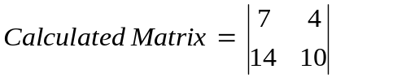

System Answer:

3BD2 = 07
093A = 14
3BBA = 04
0977 = 10

3B92 = 01 – MODE 5
OR
095D = 12 – MODE 1

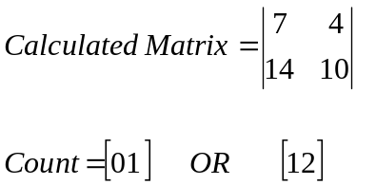

(2x2) by a (2x2) matrix multiplications

Input data

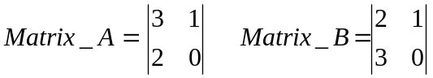 (2x2) by a (2x2) result is a 2x2

Decimal 1 demensional equivalent of the matrices data 310200000210300000

Bit stream, made up of two bit numbers 110100100000000000100100110000000000

Split the bit stream up into three bit segments starting with the LSB 110100 100000 000000 100100 110000 000000

Reverse each set of six bits, input into the XSport program 001011 000001 000000 001001 000011 000000

In MATRIX MODE 100 / 000 OR MATRIX MODE 4 / MATRIX MODE 0 the following matrix product is produced

The Calculated matrix product is shown below:-

Calculated Answer:

(3 x 2) + (1 x 3) = 9
(2 x 2) + (0 x 3) = 4

(3 x 1) + (1 x 0) = 3
(2 x 1) + (0 x 0) = 2
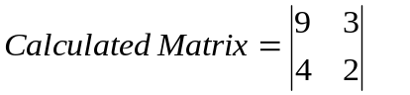

System Answer:

3BFB = 09
3BBA = 04

3BDB = 03
3BDD = 02

3B92 = 01 – MODE 4
OR
3BFF = 12 – MODE 0

